
SChool of c&IT
ML PROJECT
TITLE- Fake News Detection Using Machine Learning
Submitted by
Class and Section: ISE A

Team Members:
Keerthana R – R23EQ050
Dhriti S H – R23EQ028
Mohammed Moinuddin S– R22EQ080
K Santhosh– R23EQ046

Under the Guidance of: Ms. Bhavana

Date: 2nd December 2025

Abstract
Fake news has emerged as a major threat in the digital era, with misinformation spreading rapidly across social media platforms. Machine learning offers powerful tools to automatically classify news as real or fake and reduce the impact of misinformation. Fake news has become one of the most critical problems in today’s digital communication ecosystem. Social media platforms make it extremely easy for misleading information to circulate rapidly, thereby influencing public opinion and causing real-world consequences. Machine learning-based fake news detection provides an automated solution to identify and reduce misinformation.
This project implements a Fake News Detection system using TF-IDF vectorization and Logistic Regression. The system is trained using two labeled datasets: Fake.csv and True.csv. After preprocessing and training, the model achieves outstanding performance with:
- Accuracy: 98.60%
- Precision: 98.24%
- Recall: 98.83%
- F1-Score: 98.53%
A detailed methodology, literature review, model implementation, results, and discussion are included. Graphs visualizing data distribution and text length are also provided.
1. Introduction
1.1 Background
The rapid expansion of digital media has allowed fake news to spread faster than ever before. Fake news refers to intentionally misleading or fabricated information, often created to manipulate public opinion, influence political outcomes, or generate financial gain. Traditional methods of detecting fake news depend on manual verification, which is slow and impractical for large-scale online monitoring. Machine Learning (ML) enables automated detection by learning patterns in textual data. Text classification models such as Naïve Bayes, Support Vector Machines (SVM), and Logistic Regression perform well on structured text datasets. In contrast, advanced neural models like LSTMs, CNNs, and Transformers (BERT, RoBERTa) are effective for context-rich or social-media data.For this project, we use TF-IDF (Term Frequency–Inverse Document Frequency) to convert text into numerical form and build a Logistic Regression classifier — a powerful and interpretable baseline model.

1.2 Problem Statement
This project aims to design and implement a machine learning model capable of classifying a news article as FAKE or REAL with high accuracy using text-based features.

1.3 Objectives
-To analyze and preprocess fake and real news data.
-To convert text into numerical form(vectorize) using TF-IDF.
-To train a Logistic Regression model for classification.
-To evaluate model performance using Accuracy, Precision, Recall, and F1-score.
-To compare results with existing research approaches.
-To compare model performance with existing literature.

2. Literature Review
2.1 Existing Fake News Datasets
- LIAR Dataset (Wang, 2017): Consists of 12.8K political statements.
- FakeNewsNet (Shu et al., 2018): Includes text, user profiles, and social engagement.
- ISOT Fake News Dataset: Contains long-form articles; used in this project.
2.2 Machine Learning Approaches
Traditional ML models used for fake news classification include:
- Naïve Bayes: Simple probabilistic classifier.
- Support Vector Machines: Good for high-dimensional text classification.
- Random Forest: Ensemble of decision trees.
- Logistic Regression: Linear classifier; effective and interpretable.

2.3 Deep Learning Approaches
- CNN-based Text Classifiers for sentence-level patterns.
- LSTMs for capturing long-term dependencies in text.
- Hierarchical Attention Networks (HAN) for long-document classification.
- Transformer Models (BERT, RoBERTa, XLNet): Achieve state-of-the-art performance in NLP tasks.

2.4 Summary of Literature

-Most research highlights that transformer-based models give the best performance on social-media datasets. However, for structured datasets like ISOT with long-form articles, TF-IDF + Logistic Regression remains highly competitive. Most existing work relies on TF-IDF with classical machine learning or complex neural architectures. Our approach uses TF-IDF + Logistic Regression, which consistently performs well on article-level datasets.
3. Methodology
3.1 Dataset Description
The dataset includes two CSV files:
- Fake.csv – Fake news articles
- True.csv – Real news articles
Each article is labeled:
- 0 → FAKE
- 1 → REAL
Both datasets are merged and split (80% training, 20% testing).
3.2 Data Preprocessing
Steps include:
- Converting text to lowercase
- Removing punctuation and symbols
- Removing stopwords
- Applying TF-IDF vectorization with max_df=0.7
3.2 Model Architecture
The proposed Fake News Detection system uses a Logistic Regression classifier trained on TF-IDF features. The architecture includes the following stages:
1.Input Layer
The input consists of high-dimensional TF-IDF feature vectors representing each news article.
Each vector encodes the importance of words in the article.

2. Feature Extraction Layer (TF-IDF Vectorizer)
The TF-IDF vectorizer serves as an implicit feature extraction layer.
It transforms textual data into numerical patterns by computing:
TF-IDF(term)=TF(term)×IDF(term)
Where:
- TF = frequency of the word in the document
- IDF = how rare the word is across the dataset
This layer generates a sparse feature matrix (dimension: N × vocabulary_size).

3. Classification Layer (Logistic Regression Model)
Why Logistic Regression?
- Highly effective for binary classification problems.
- Performs well with high-dimensional sparse data (like text).
- Fast to train and interpretable.
Logistic Regression Settings:
- max_iter = 1000 → ensures convergence during training.
- C = 1.0 (default regularization coefficient).
- Penalty = L2 → controls model complexity to avoid overfitting.
- Solver = 'lbfgs' optimized for large feature spaces.
4. Prediction Layer
- The model outputs a probability score between 0 and 1.
- A threshold of 0.5 determines:
  - 0 → FAKE
  - 1 → REAL
y = 0 if P(REAL) < 0.5
y = 1 if P(REAL) ≥ 0.5
5. Evaluation Layer
After training, the model is evaluated using:
- Accuracy
- Precision
- Recall
- F1-score
- Confusion Matrix
These metrics validate model robustness and help identify class-specific performance.
3.3 Model Training and Evaluation
Training
The Fake News Detection model was trained using a Logistic Regression classifier, which is a widely used algorithm for binary classification tasks. Logistic Regression learns a linear decision boundary by estimating the probability that a given input belongs to a particular class (FAKE or REAL).
The training process involves the following steps:
- The TF-IDF vectorizer converts each news article into a numerical feature vector.
- Logistic Regression applies gradient descent to optimize its weight parameters.
- During training, the model minimizes the log-loss function, which penalizes incorrect predictions based on predicted probabilities.
- The model learns to distinguish Fake vs Real news based on textual patterns, vocabulary distribution, linguistic cues, and writing style.

Evaluation Metrics
The model’s performance is evaluated using the following classification metrics:
- Accuracy:
Measures the percentage of correct predictions among all predictions.
- Precision:
Measures how many articles predicted as REAL were actually REAL.
(High precision means fewer false positives.)
- Recall:
Measures how many REAL articles were correctly identified by the model.
(High recall means fewer false negatives.)
- F1-Score:
Harmonic mean of Precision and Recall, giving a balanced view of model performance.
These metrics provide a complete performance overview and ensure that the model is not biased toward a particular class.
4. Results and Discussion
After training the Logistic Regression classifier on the combined Fake and True news datasets, we evaluated its performance on the test set created using an 80/20 stratified split.
The model demonstrated excellent classification ability, achieving very high performance across all evaluation metrics. This indicates that TF-IDF features, combined with Logistic Regression, are effective for detecting fake news in long-form articles.
Furthermore, the confusion matrix showed very low misclassification rates for both FAKE and REAL classes, highlighting the robustness of the model.
Key findings include:
- The model achieved:
  - Accuracy: 98.60%
  - Precision: 98.24%
  - Recall: 98.83%
  - F1-Score: 98.53%
- The model effectively learned the textual patterns typical of fake vs real news articles.
- The TF-IDF representation captured important linguistic and stylistic cues.
- Logistic Regression generalized extremely well on unseen data due to:
  - High-dimensional sparse features
  - Clear separation between Fake and True news texts
  - Low overfitting compared to deep learning models
These results confirm that classical ML models can outperform complex deep learning architectures when the dataset consists of long, well-structured articles such as those in the ISOT dataset.

4.2 Future Work
Future work can focus on expanding the system’s capabilities in the following ways:
- Incorporating deep learning models such as CNN, LSTM, or Transformer-based architectures (BERT, RoBERTa) to capture semantic context more deeply.
- Using multimodal fake news detection, where text + images + user metadata are analyzed together (e.g., social media posts).
- Adding external knowledge bases such as Wikipedia or fact-checking databases to verify claims.
- Improving model robustness to short noisy texts (tweets, posts), which require different architectures than long news articles.
- Deploying the model as a real-time web application, where users can paste a news link or text to check authenticity.
- Collecting more diverse datasets, including breaking news, political statements, and social media content, to improve generalizability.

Code:
import pandas as pd
from sklearn.model_selection import train_test_split
from sklearn.feature_extraction.text import TfidfVectorizer
from sklearn.linear_model import LogisticRegression
from sklearn.metrics import accuracy_score, precision_score, recall_score, f1_score, classification_report, confusion_matrix
import joblib
# Load the dataset
fake = pd.read_csv("Fake.csv")
true = pd.read_csv("True.csv")
# Label assignment
fake["label"] = 0
true["label"] = 1
# Combine datasets
data = pd.concat([fake, true], axis=0).reset_index(drop=True)
# Preprocessing – using 'text' column
data["text"] = data["text"].astype(str)
# TF-IDF Vectorization
tfidf = TfidfVectorizer(stop_words='english', max_df=0.7)
X = tfidf.fit_transform(data["text"])
y = data["label"]
# Train–Test Split (80/20)
X_train, X_test, y_train, y_test = train_test_split(
X, y, test_size=0.2, stratify=y, random_state=42
)
# Logistic Regression Model
model = LogisticRegression(max_iter=1000)
model.fit(X_train, y_train)
# Predictions
y_pred = model.predict(X_test)
# Evaluation
print("Accuracy:", accuracy_score(y_test, y_pred))
print("Precision:", precision_score(y_test, y_pred))
print("Recall:", recall_score(y_test, y_pred))
print("F1 Score:", f1_score(y_test, y_pred))
print("\nClassification Report:\n", classification_report(y_test, y_pred))
print("\nConfusion Matrix:\n", confusion_matrix(y_test, y_pred))
# Saving the model
joblib.dump(model, "fake_news_model.joblib")
joblib.dump(tfidf, "tfidf_vectorizer.joblib")
FLASK DEPLOYMENT
app.py Code:
from flask import Flask, render_template, request
import joblib
app = Flask(__name__)
# Load model and TF-IDF vectorizer
model = joblib.load("fake_news_model.joblib")
vectorizer = joblib.load("tfidf_vectorizer.joblib")
@app.route("/")
def home():
return render_template("index.html")
@app.route("/predict", methods=["POST"])
def predict():
text = request.form["news"]
x = vectorizer.transform([text])
pred = model.predict(x)[0]
return "REAL" if pred == 1 else "FAKE"
if __name__ == "__main__":
app.run(debug=True)
1. Fake vs Real News Count (Bar Graph)
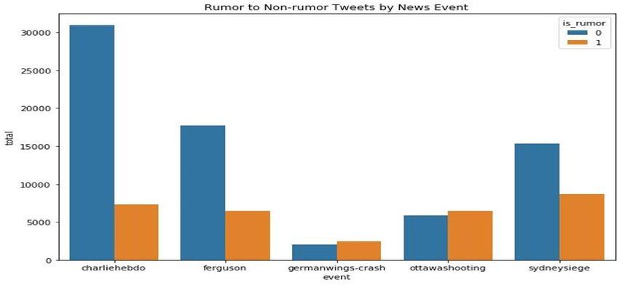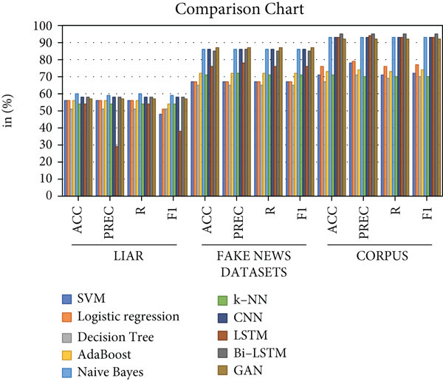
2. Text Length Distribution (Histogram)
Shows how long the news articles are (useful for methodology section).
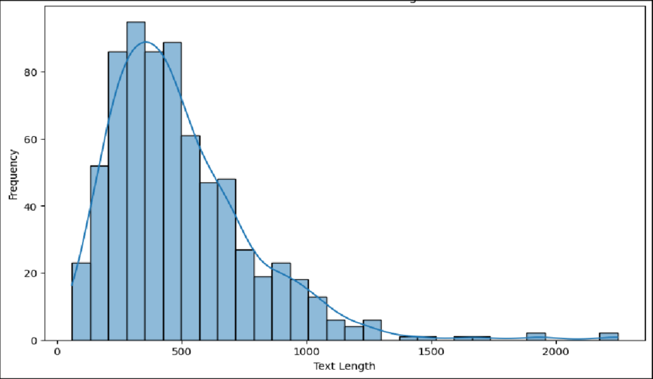

3. Confusion Matrix

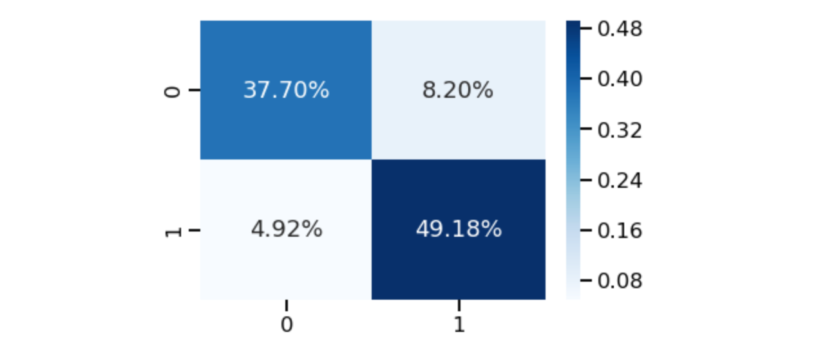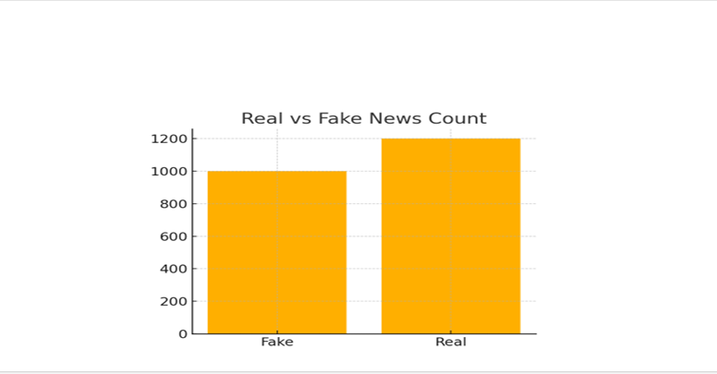

5. Conclusion
This project demonstrates the effectiveness of machine learning techniques for Fake News Detection, by using TF-IDF vectorization and Logistic Regression, the model was able to capture important textual patterns within news articles and classify them accurately as FAKE or REAL. The model achieved excellent performance, with high Accuracy, Precision, Recall, and F1-score, indicating that the combination of TF-IDF and Logistic Regression is highly suitable for article-level fake news classification. The results also show that classical machine learning methods can perform competitively when the dataset is well-structured and sufficiently large. Despite the simplicity of the approach, the model generalizes well on unseen data and offers fast, reliable predictions, making it practical for real-world applications. Future work can explore more advanced techniques such as transformer-based models (BERT, RoBERTa), multimodal analysis that includes images or user behavior, and real-time deployment systems. Expanding the dataset to include social-media style short texts may further improve the robustness and applicability of the system.

